5.0 FIRST AID FACILITIES

5.1 Adequate Supplies

We must ensure that adequate first aid facilities and supplies are available for all employees and visitors. The first aid kit contents shall be documented on a list located in the first aid kit. The first aid kit is to be checked and re-stocked monthly by the Responsible Person or a delegated person.

Tip: First Aid supply companies provide this service ensuring suitable supplies are on hand and can top up supplies on a regular basis.

5.2 Trained First Aider

As part of our emergency response plan we should have a first aid responder on site. Adequate staff need to be trained to provide this service.

First Aid Notice
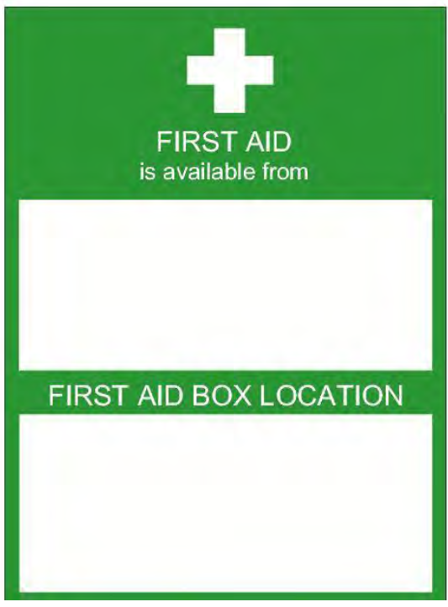

Action: Complete this ‘First Aid Sign form’ with First Aider name and location of First Aid Kit. Display this notice in all work areas.

